Schematic Design

Kicad 7.0 Schematic editor is used For designing the schematic of the calculator. The design mainly have five categories.
- Power Schematic:
- Voltage regulator which is able to give a voltage input from 4.5V to 18V and the current input varies from 1.5A,2.5A. It is a triple synchronous and a step-down Converter.

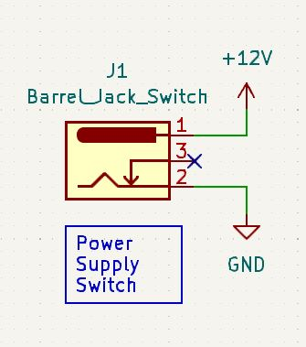

- Power Supply Switch: J1 Barrel_Jack_Switch is used.
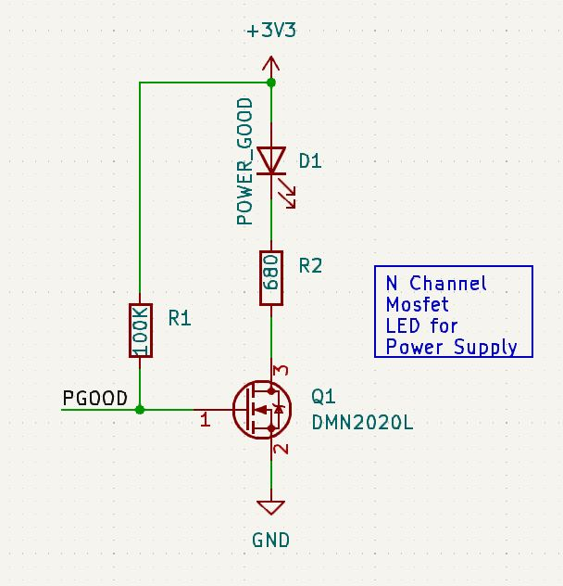

- LED: N channel MOSFET LED for Power supply is used it is included with Q1 DMN2020L N channel MOSFET, an LED and 100k and 680 ohm resistors have been used.

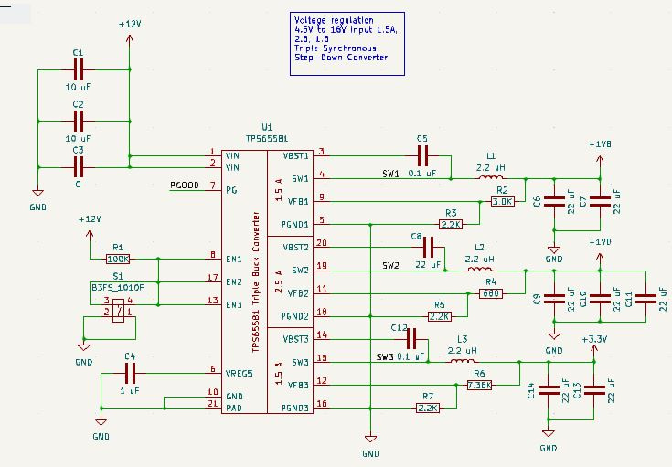

- Keypad Schematic: This is an external input device have been used in the project. It is included with 4 columns and 4 rows together with 16 push buttons. It is included with the global labels such as ROW 1 to 4 and Col 1 to 4 in order to connect the schematic with the other hierarchical schematics.

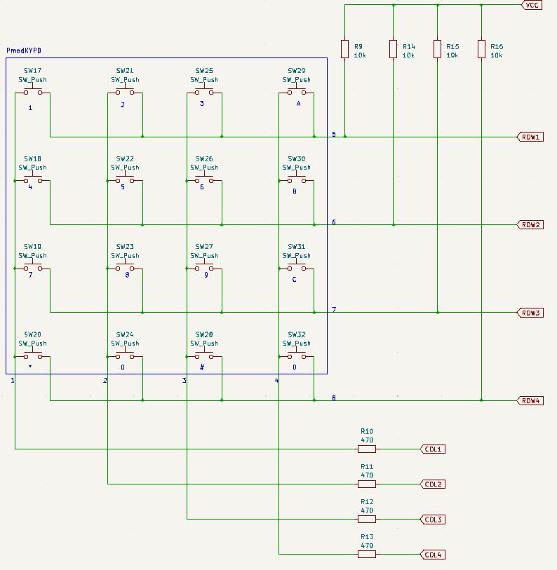
- FPGA Schematic:
- Ground: The schematic to represent Grounded pins
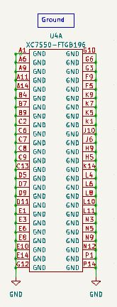
- Power Input: The schematic to represent Power inputs
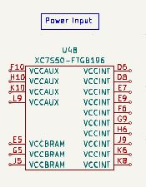
- Input Outputs: The schematic to represent Input and Outputs
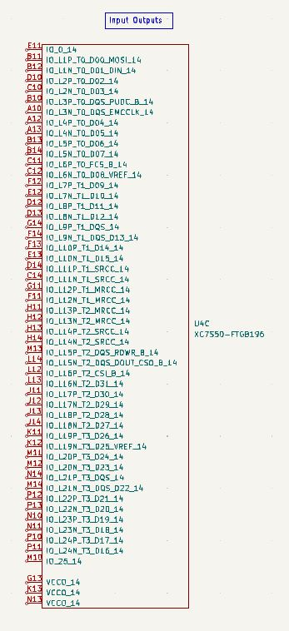

- Seven Segment display Schematic: Two seven segments displays(U2 CC 56-12CGKWA) are used.
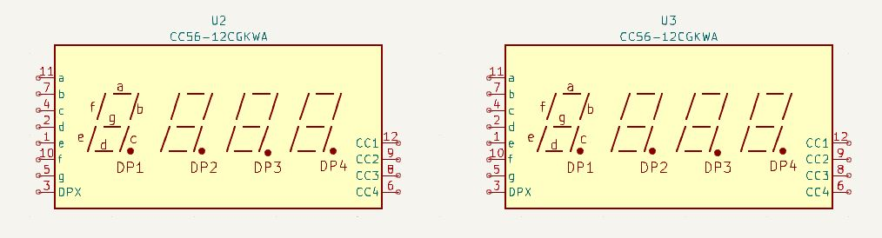

- FPGA JTAG Interface Schematic:

- FPGA JTAG Interface
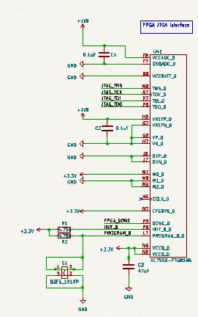
- Pin Header for Xilinx JTAG programmer
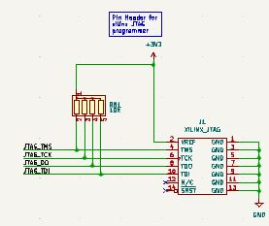
- Clock: Oscillator 2KHz to 100MHz
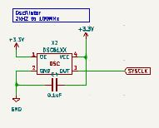
- Tactile Switch: Used for the reset switch
